Lab 1 Practice:
Learning Outcome:
- explore the SQL Developer environment
- execute SQL DDL commands
- insert data
- query data
Student Learning Time (SLT): 3 hours

Instruction:
- Log in to Oracle via SQL Developer.
- Create all 8 tables provided below (refer to the HR ERD in the Appendix, #Note table job grade is not drawn in the HR schema relationship diagram)
- Insert all data into the tables
** All tables and data should be completed and available for use during our next lab (Week 2).

- Region
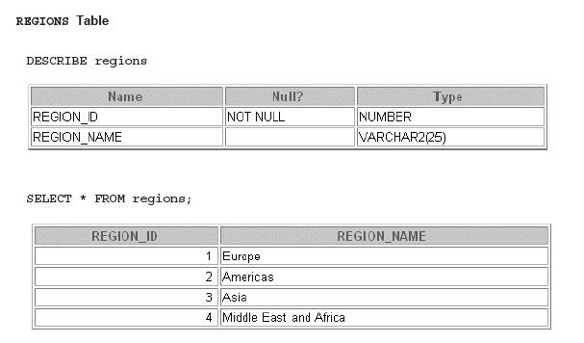
create table regions (
region_id number,
region_name varchar2(25),
constraint regions_pk PRIMARY KEY (region_id));
insert into regions(region_id, region_name) values (1, 'Europe');
insert into regions values (2, 'Americas');

- Countries
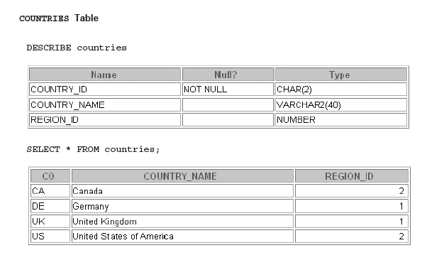
create table countries (
country_id char(2),
country_name varchar2(40),
region_id number,
constraint countries_pk PRIMARY KEY (country_id),
constraint countries_fk FOREIGN KEY (region_id) references regions (region_id)
);
insert into countries values ('CA', 'Canada', 2);
insert into countries values ('DE', 'Germany', 1);

- Locations
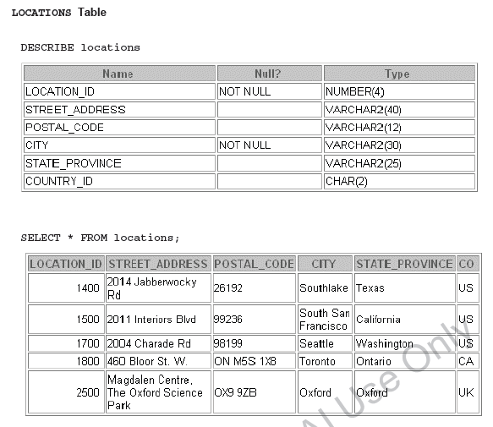
create table locations (
location_id number(4),
street_address varchar2(40),
postal_code varchar2(12),
city varchar2(30) not null,
state_province varchar2(25),
country_id char(2),
constraint locations_pk PRIMARY KEY (location_id),
constraint locations_fk FOREIGN KEY (country_id) references countries(country_id)
);

insert into locations values (1400, '2014 Jabberwocky Rd', '26192', 'Southlake', 'Texas', 'US');
insert into locations values (1500, '2011 Interiors Blvd', '99236', 'South San Francisco', 'California', 'US');

- Departments
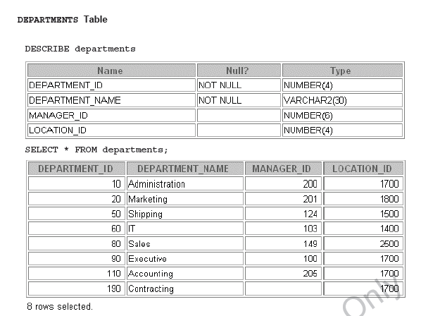
create table departments ( department_id number(4),
department_name varchar2(30) not null,
manager_id number(6),
location_id number(4),
constraint departments_pk PRIMARY KEY (department_id),
constraint dept_fk1FOREIGN KEY (location_id) references location(location_id)
);

insert into departments values (10, 'Administration', 200, 1700);
insert into departments values (20, 'Marketing', 201, 1800);
insert into departments values (50, 'Shipping', 124, 1500);
insert into departments values (60, 'IT', 103, 1400);

- Jobs
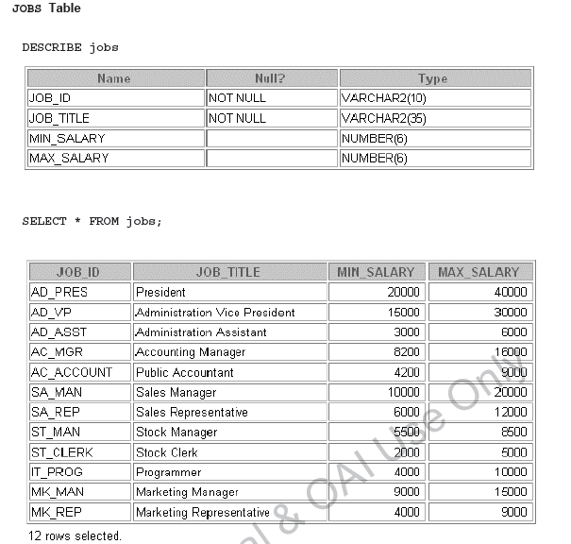
create table jobs (
job_id varchar2(10),
job_title varchar2(35) not null, min_salary number(6),
max_salary number(6),
constraint jobs_pk PRIMARY KEY (job_id));
insert into jobs values ('AD_PRES', 'President', 20000, 40000);
insert into jobs values ('AD_VP', 'Administration Vice President', 15000, 30000);
insert into jobs values ('AD_ASST', 'Administration Assistant', 3000, 6000); i
nsert into jobs values ('AC_MGR', 'Accounting Manager', 8200, 16000);
insert into jobs values ('AC_ACCOUNT', 'Public Accountant', 4200, 9000);
insert into jobs values ('SA_MAN', 'Sales Manager', 10000, 20000);
insert into jobs values ('SA_REP', 'Sales Representative', 6000, 12000);

- Employees
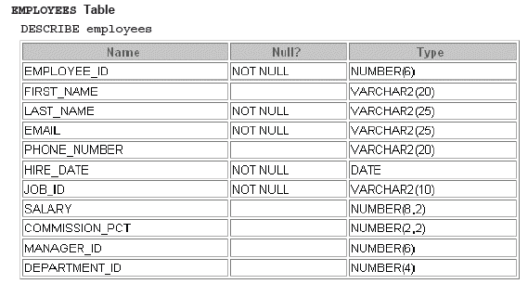
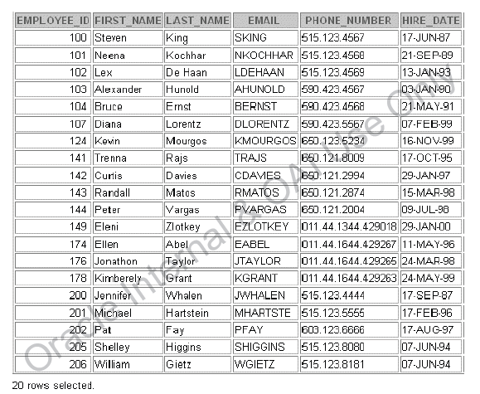
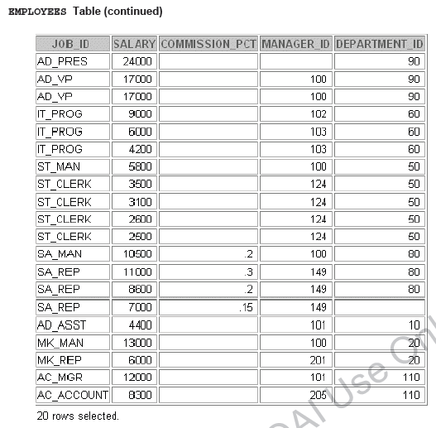
create table employees (
employee_id number(6) not null,
first_name varchar2(20),
last_name varchar2(25) not null,
email varchar2(25) not null,
phone_number varchar2(20),
hire_date date not null,
job_id varchar2(10) not null,
salary number(8,2),
commission_pct number(2,2),
manager_id number(6),
department_id number(4),
constraint employees_pk PRIMARY KEY (employee_id),
constraint emp_fk FOREIGN KEY (department_id) references departments (department_id));

insert into employees values (100, 'Steven', 'King', 'SKING', '515.123.4567', '17-JUN-87', 'AD_PRES', 24000, null, null, 90);
insert into employees values (101, 'Neena', 'Kochhar', 'NKOCHHAR', '515.123.4568', '21-SEP- 89', 'AD_VP', 17000, null, 100, 90);
insert into employees values (102, 'Lex', 'De Haan', 'LDEHAAN', '515.123.4569', '13-JAN-93', 'AD_VP', 17000, null, 100, 90);
insert into employees values (103, 'Alexander', 'Hunold', 'AHUNOLD', '590.423.4567', '03- JAN-90', 'IT_PROG', 9000, null, 102, 60);
insert into employees values (104, 'Bruce', 'Ernst', 'BERNST', '590.423.4568', '21-MAY-91', 'IT_PROG', 6000, null, 103, 60);
insert into employees values (107, 'Diana', 'Lorentz', 'DLORENTZ', '590.423.5567', '07-FEB- 99', 'IT_PROG', 4200, null, 103, 60);
insert into employees values (124, 'Kevin', 'Mourgos', 'KMOURGOS', '650.123.5234', '16- NOV-99', 'ST_MAN', 5800, null, 100, 50);
insert into employees values (141, 'Trenna', 'Rajs', 'TRAJS', '650.121.8009', '17-OCT-95', 'ST_CLERK', 3500, null, 124, 50);
insert into employees values (142, 'Curlis', 'Davies', 'CDAVIES', '650.121.2994', '29-JAN-97', 'ST_CLERK', 3100, null, 124, 50);
insert into employees values (143, 'Randall', 'Matos', 'RMATOS', '650.121.2874', '15-MAR- 98', 'ST_CLERK', 2600, null, 124, 50);
insert into employees values (144, 'Peter', 'Vargas', 'PVARGAS', '650.121.2004', '09-JUL-98', 'ST_CLERK', 2500, null, 124, 50);
insert into employees values (149, 'Eleni', 'Zlotkey', 'EZLOTKEY', '011.44.1344.429018', '29- JAN-00', 'SA_MAN', 10500, .2, 100, 80);
insert into employees values (174, 'Ellen', 'Abel', 'EABEL', '011.44.1644.429267', '11-MAY-96', 'SA_REP', 11000, .3, 149, 80);
insert into employees values (176, 'Jonathon', 'Taylor', 'JTAYLOR', '011.44.1644.429265', '24- MAR-98', 'SA_REP', 8600, .2, 149, 80);
insert into employees values (178, 'Kimberely', 'Grant', 'KGRANT', '011.44.1644.429263', '24- MAY-99', 'SA_REP', 7000, .15, 149, null);
insert into employees values (200, 'Jennifer', 'Whalen', 'JWHALEN', '515.123.4444', '17-SEP- 87', 'AD_ASST', 4400, null, 101, 10);
insert into employees values (201, 'Michael', 'Hartstein', 'MHARTSTE', '515.123.5555', '17- FEB-96', 'MK_MAN', 13000, null, 100, 20);
insert into employees values (202, 'Pat', 'Fay', 'PFAY', '603.123.6666', '17-AUG-97', 'MK_REP', 6000, null, 201, 20);
insert into employees values (205, 'Shelley', 'Higgins', 'SHIGGINS', '515.123.8080', '07-JUN- 94', 'AC_MGR', 12000, null, 101, 110);
insert into employees values (206, 'William', 'Gietz', 'WGIETZ', '515.123.8181', '07-JUN-94', 'AC_ACCOUNT', 8300, null, 205, 110);

- Job History
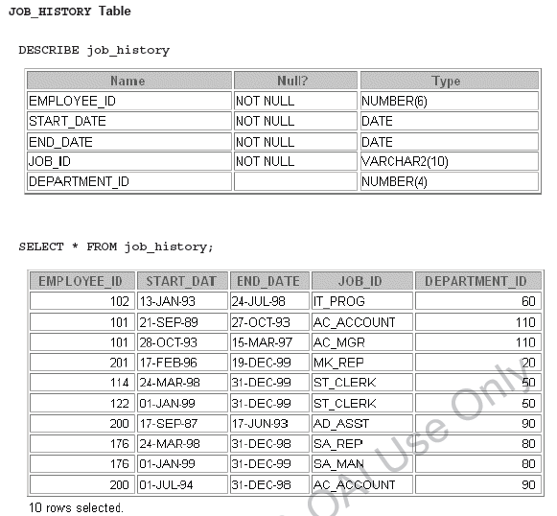

create table job_history (
employee_id number(6),
start_date date not null,
end_date date not null,
job_id varchar2(10) not null,
department_id number(4),
constraint job_history_pk primary key (employee_id, start_date));
insert INTO job_history values (102, '13-JAN-93', '24-JUL-98', 'IT_PROG', 60);
insert INTO job_history values (101, '21-SEP-89', '27-OCT-93', 'AC_ACCOUNT', 110);
insert INTO job_history values (101, '28-OCT-93', '15-MAR-97', 'AC_MGR', 110);
insert INTO job_history values (201, '17-FEB-96', '19-DEC-99', 'MK_REP', 20);
insert INTO job_history values (114, '24-MAR-98', '31-DEC-99', 'ST_CLERK', 50);
insert INTO job_history values (122, '01-JAN-99', '31-DEC-99', 'ST_CLERK', 50);

- Job Grades (not included in the HR ERD)
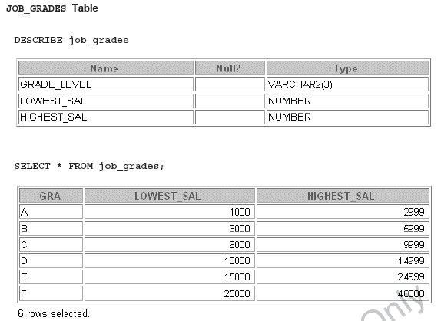
create table job_grades (
grade_level varchar2(3),
lowest_sal number,
highest_sal number);

insert into job_grades values ('A', 1000, 2999);
insert into job_grades values ('B', 3000, 5999);
insert into job_grades values ('C', 6000, 9999);

Appendix
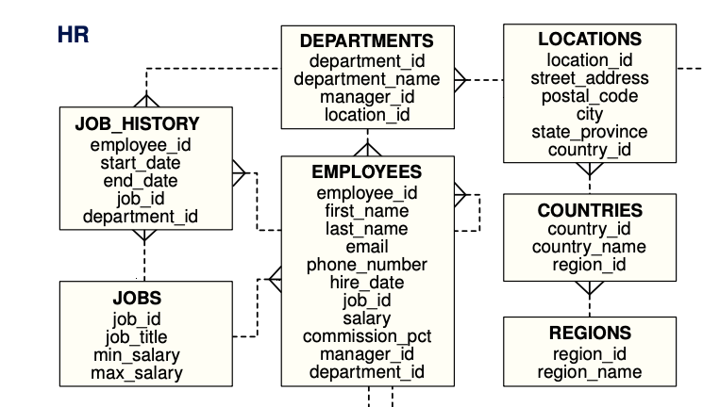
Entity Relationship Diagram (ERD) for HR

Example syntax to create table:
- Without input check
CREATE TABLE room (
roomID number,
building char(1) not null ,
roomNo varchar2(10),
maxCapacity number,
style varchar2(15),
CONSTRAINT room_pk PRIMARY KEY (roomID));

- With input check
CREATE TABLE room (
roomID number,
bldg char(1) CHECK (bldg IN ('A','B')),
roomNo varchar2(10),
maxCapacity number,
style varchar2(15) CHECK (style IN ('LECTURE',
'LECTURE/LAB', 'LAB','OFFICE')),
CONSTRAINT room_pk PRIMARY KEY (roomID));

Example syntax to insert data:
insert into room (roomId, building, roomNo, maxCapacity, style) values (1, ‘A’, ‘A1.01’, 30, ‘LECTURE’);
OR
insert into room values (1, ‘A’, ‘A1.01’, 30, ‘LECTURE’);

